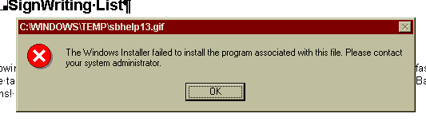
The Windows Installer failed to install the program associated with this file. Please contact your system administrator

